
NAME: | M.PRAVEEN REDDY
ID: | 2400032662
SECTION: | S-3
SUBJECT: | FULL STACK APPLICATION  DEVELOPMENT

#SKILL - 1 Git Version Control
Tasks:

Create a new project folder, initialize Git using git init, and configure Git with your username and email.
Commands Used:- mkdir MyGitProject cd MyGitProject

git init
git config user.name "Your Name"
git config user.email "youremail@example.com"

Output:-
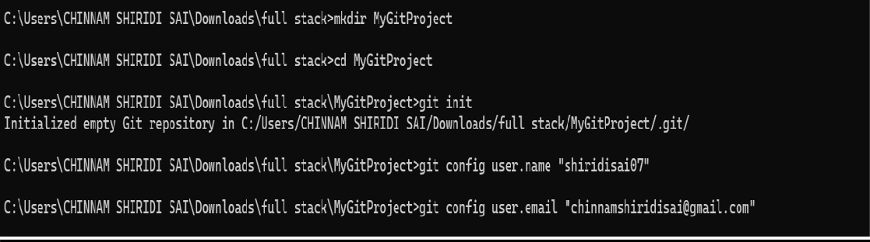

Create two files (example: main.java, notes.txt) with sample content, check the repository status, and add them to staging.

Commands Used:-
echo public class Main { public static void main(String[] args) { System.out.println("Hello Git!"); } } > main.java
echo This is my first Git project. > notes.txt

git status
git add main.java notes.txt

Output:-
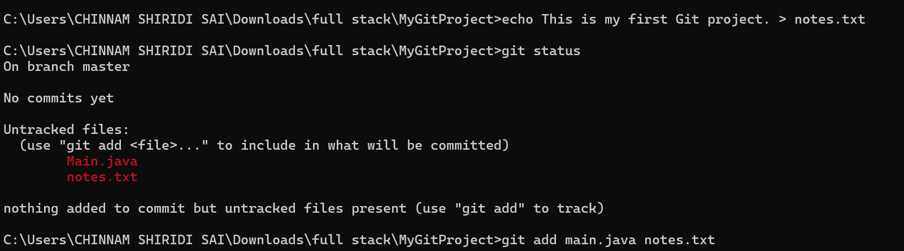

Commit the staged files with a meaningful commit message.

Commands Used:-
git commit -m "Initial commit: add main.java and notes.txt"

Output:-

Create a new repository on GitHub, connect your local repo using the remote URL and push the committed changes.

Commands Used:-
git branch -M main
git remote add origin https://github.com/USERNAME/MyGitProject.git git push -u origin main

Output:-
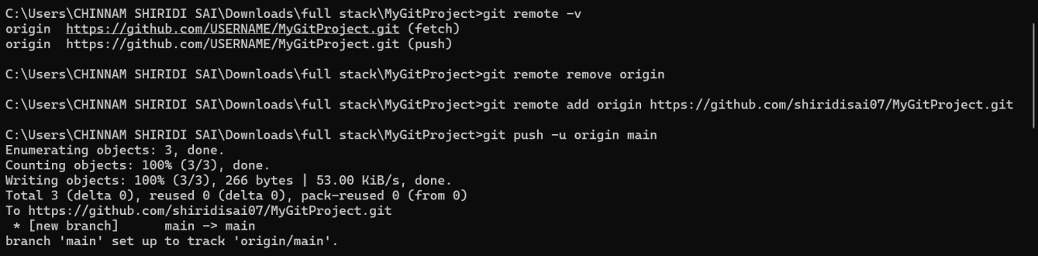

Create the first branch (example: feature-update), make modifications, and add + commit the changes.

Commands Used:-
git checkout -b feature-update
echo Added feature update notes. >> notes.txt git add notes.txt
git commit -m "Add feature update notes"

Output:-
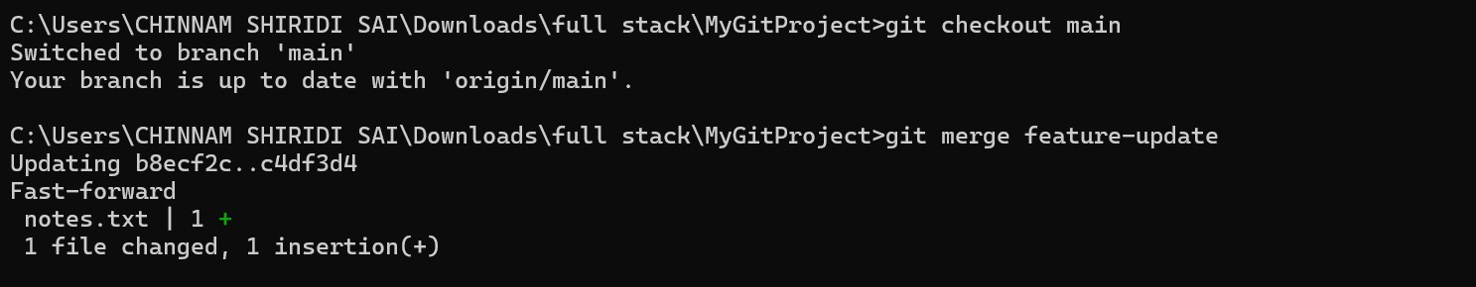

Create a second branch (example: bug-fix), apply changes, and add + commit them.

Commands Used:-
git checkout main
git checkout -b bug-fix
echo System.out.println("Bug fixed!"); >> main.java git add main.java
git commit -m "Fix bug in main.java"

Output:-
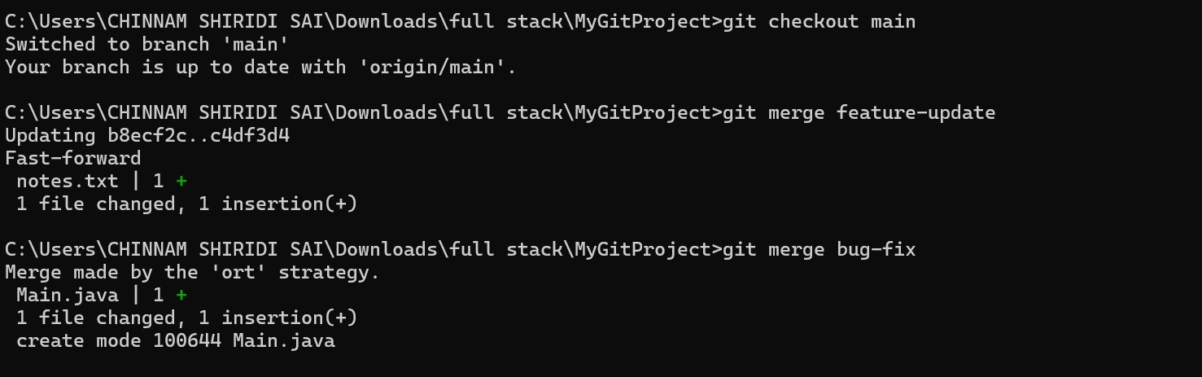

Switch back to the main branch and merge both branches one after the other.

Commands Used:-
git checkout main
git merge feature-update git merge bug-fix

Output:-
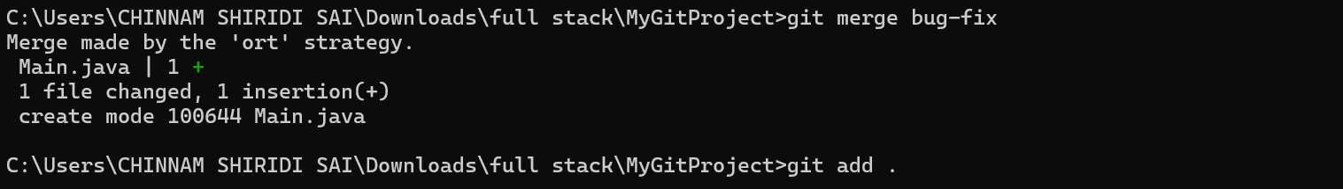

If any merge conflict occurs, resolve it manually, commit the fix, and complete the merge

Commands Used:-
git add .
git commit -m "Resolve merge conflict"

Output:-
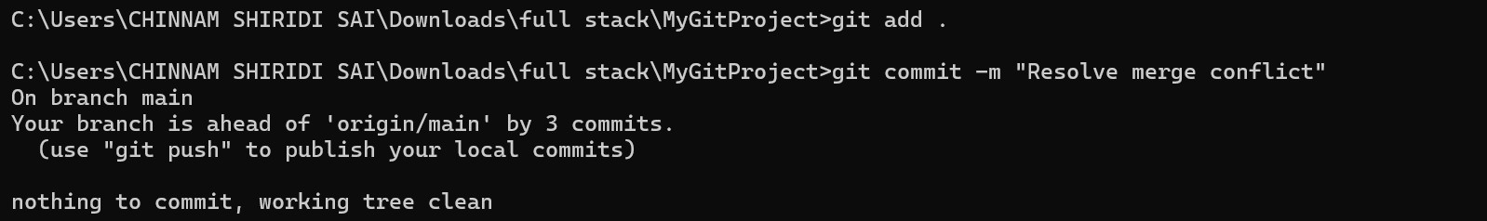

Final GitHub Repo:- 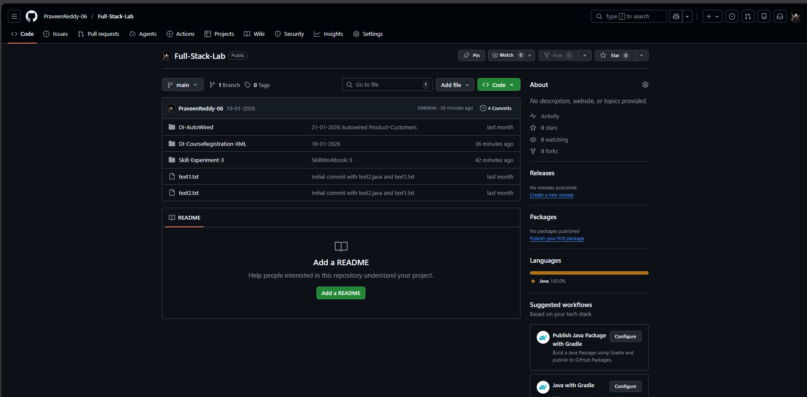

Git Hub link: PraveenReddy-06/Full-Stack-Lab
Conclusion:-

In this experiment, Git was successfully used as a version control system to manage a project efficiently. The repository was initialized, user configuration was completed, and files were created, staged, and committed following the Git life cycle. Multiple branches were created to handle feature updates and bug fixes independently, ensuring safe and organized development. These branches were later merged into the main branch, demonstrating effective branch management and merge operations. Finally, the project was pushed to a remote GitHub repository, enabling centralized storage and version tracking. This exercise provided hands-on experience with essential Git commands and workflows used in real-world software development.

